In computer graphics, transformation of the coordinates consists of three major processes:

Translation

* Rotation
* Scaling

**What is translation?**

A translation process moves every point a constant distance in a specified direction. It can be described as a rigid motion. A translation can also be interpreted as the addition of a constant vector to every point, or as shifting the origin of the coordinate system.  
Suppose, If point (X, Y) is to be translated by amount Dx and Dy to a new location (X’, Y’) then new coordinates can be obtained by adding Dx to X and Dy to Y as:

X' = Dx + X

Y' = Dy + Y

or P' = T + P where

P' = (X', Y'),

T = (tx, ty ),

P = (X, Y)

Here, P(X, Y) is the original point. T(tx, ty) is the **translation factor**, i.e. the amount by which the point will be translated. P'(X’, Y’) is the coordinates of point P after translation.  
Examples:

Input : P[] = {5, 6}, T = {1, 1}

Output : P'[] = {6, 7}

Input : P[] = {8, 6}, T = {-1, -1}

Output : P'[] = {7, 5}

**Rotation**

In order to rotate an object we need to rotate each vertex of the figure individually.  
On rotating a point P(x, y) by an angle A about the origin we get a point P'(x’, y’). The values of x’ and y’ can be calculated as follows:-

[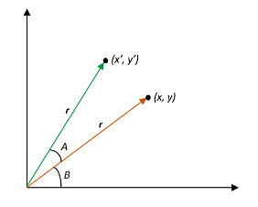](http://cdncontribute.geeksforgeeks.org/wp-content/uploads/Rotation-Diagram.png)

We know that,  
x = rcosB, y = rsinB

x’ = rcos(A+B) = r(cosAcosB – sinAsinB) = rcosBcosA – rsinBsinA = **xcosA – ysinA**  
y’ = rsin(A+B) = r(sinAcosB + cosAsinB) = rcosBsinA + rsinBcosA = **sinA + ycosA**

x’ cos() -sin() x

y’ sin() cos() y

=

**Scaling**

A scaling transformation alters size of an object. In the scaling process, we either compress or expand the dimension of the object.  
Scaling operation can be achieved by multiplying each vertex coordinate (x, y) of the polygon by scaling factor sx and sy to produce the transformed coordinates as (x’, y’).  
So, x’ = x * sx and y’ = y * sy.  
The scaling factor sx, sy scales the object in X and Y direction respectively. So, the above equation can be represented in matrix form:  
  
Or P’ = S . P  
Scaling process:  
https://cdncontribute.geeksforgeeks.org/wp-content/uploads/transformation.png

Shearing:

It is transformation which changes the shape of object. The sliding of layers of object occur. The shear can be in one direction or in two directions.

**Shearing in the X-direction:** In this horizontal shearing sliding of layers occur. The homogeneous matrix for shearing in the x-direction is shown below:

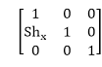   
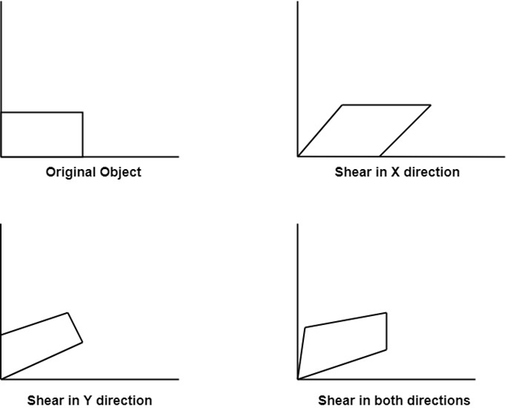

**Shearing in the Y-direction:** Here shearing is done by sliding along vertical or y-axis.

Shearing

**Shearing in X-Y directions:** Here layers will be slided in both x as well as y direction. The sliding will be in horizontal as well as vertical direction. The shape of the object will be distorted. The matrix of shear in both directions is given by:

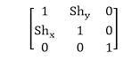

# Reflection:

It is a transformation which produces a mirror image of an object. The mirror image can be either about x-axis or y-axis. The object is rotated by180°.

## **Types of Reflection:**

1. Reflection about the x-axis
2. Reflection about the y-axis
3. Reflection about an axis perpendicular to xy plane and passing through the origin
4. Reflection about line y=x

**1. Reflection about x-axis:** The object can be reflected about x-axis with the help of the following matrix

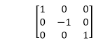

In this transformation value of x will remain same whereas the value of y will become negative. Following figures shows the reflection of the object axis. The object will lie another side of the x-axis.

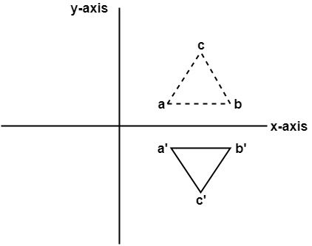

**2. Reflection about y-axis:** The object can be reflected about y-axis with the help of following transformation matrix

Reflection

Here the values of x will be reversed, whereas the value of y will remain the same. The object will lie another side of the y-axis.

The following figure shows the reflection about the y-axis

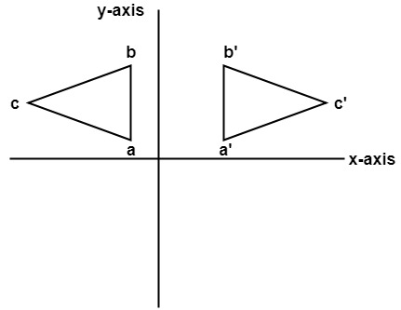

**3. Reflection about an axis perpendicular to xy plane and passing through origin:**  
In the matrix of this transformation is given below

Reflection   
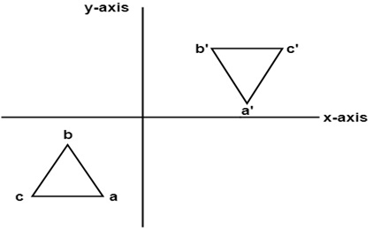

In this value of x and y both will be reversed. This is also called as half revolution about the origin.

**4. Reflection about line y=x:** The object may be reflected about line y = x with the help of following transformation matrix

Reflection   
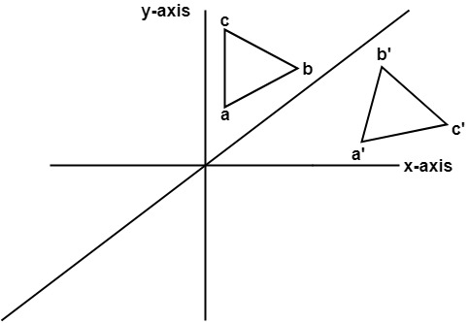

First of all, the object is rotated at 45°. The direction of rotation is clockwise. After it reflection is done concerning x-axis. The last step is the rotation of y=x back to its original position that is counterclockwise at 45°.

**Example:** A triangle ABC is given. The coordinates of A, B, C are given as

                    A (3 4)  
                    B (6 4)  
                    C (4 8)

Find reflected position of triangle i.e., to the x-axis.

**Solution:**

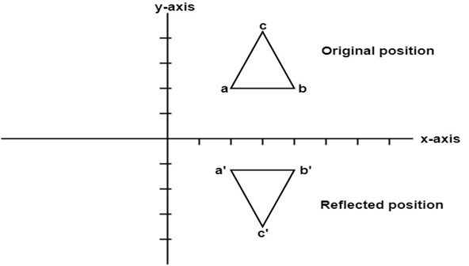   
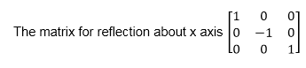

The a point coordinates after reflection

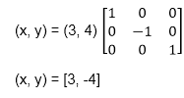

The b point coordinates after reflection

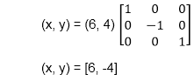

The coordinate of point c after reflection

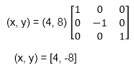

a (3, 4) becomes a1 (3, -4)  
b (6, 4) becomes b1 (6, -4)  
c (4, 8) becomes c1 (4, -8)